TITLE
A.A. NOM ¹, B.B NOM¹, C.C. NOM²
1 : Laboratory, University, adress Zip code, Town, Country
e-mail
2 : Laboratory, University, adress Zip code, Town, Country
e-mail
Summary will not exceed 2 pages length including figures and references

Section 1 (Time new roman, 12, bold)

Sub section (Time new roman, 11, Italic)
The whole document will be written in Times or Times New Roman, size 11. Title will be written in majuscule, size 14. Author’s names (Style « Authors ») will be written in fonts 11.
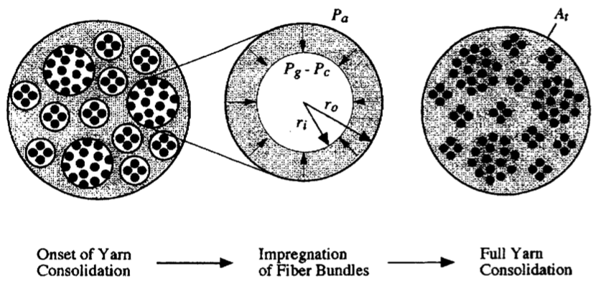
Fig. 1 – Schematic of a representative yarn cross-section and the assumed consolidation process [1]

Images/figures will be centered in the page (Style « Illustrations ») followed by caption (fonts 11 in italic).

Sous-Section2

Conclusions

References
- Bernet N., Michaud V., Bourban P.-E. Manson J.-A. E. An impregnation model for the consolidation of thermoplastic composites made from commingled yarns. J. Compos. Mater. 33(8); p. 751-772, 1999.
- Gebart B.R. Permeability of unidirectional reinforcements for RTM. J. Compos. Mater. 26(8); p. 1100-1133, 1992.

